J. S. Bach
Five cello suite, BWV 1007-1011
adapted and performed on bass guitar by
Mario D´Amato

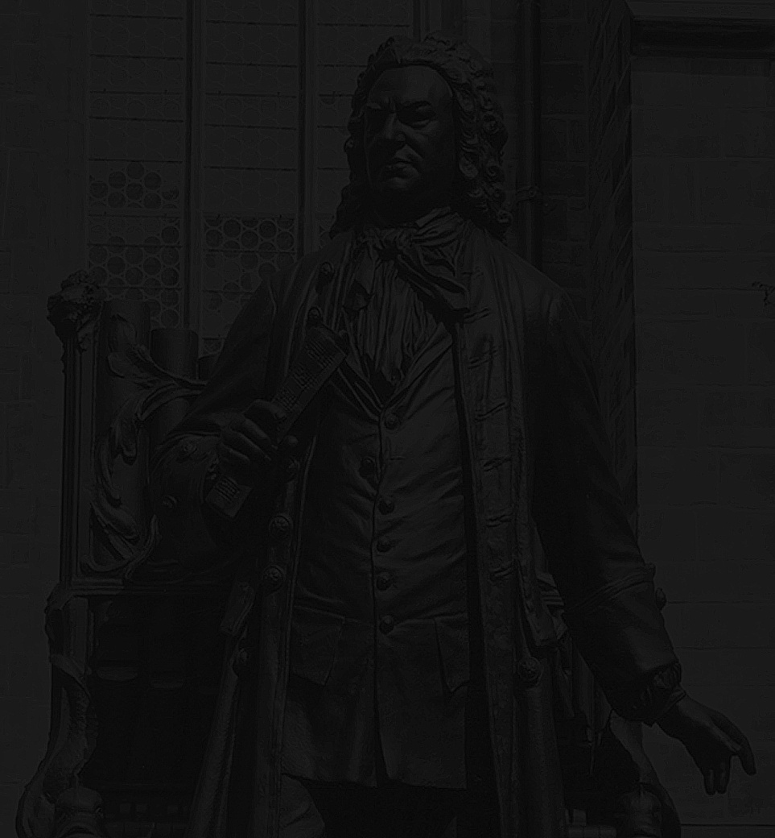

Johann Sebastian Bach (1685-1750)

Suite No. 1 in G Major, BWV 1007.......................................................20:27
Suite No. 2 in D Minor, BWV 1008......................................................23:26
Suite No. 3 in C Major, BWV 1009.......................................................26:16
Suite No. 4 in BbMajor, BWV 1010......................................................28:32
Suite No. 5 in C Minor, BWV 1011......................................................30:28

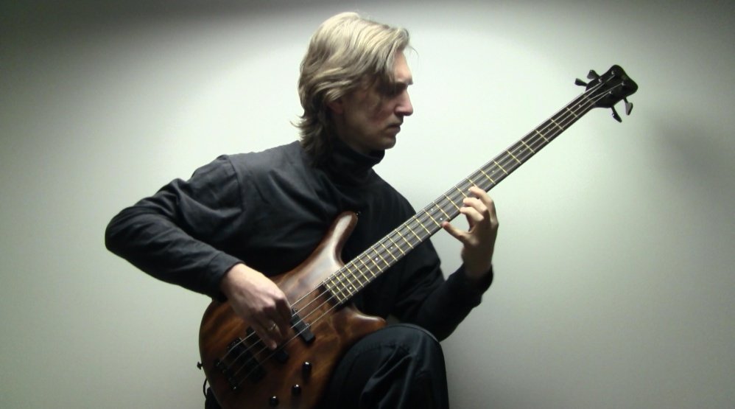
Recorded in Helsinki, November 2015
Sound Editing & mastering: Toni Armetta/MIA records
DVD authoring: Olli Perttula/MediaStage Ky

